Shipper Owned Container (“SOC”)
Request Form
To: A.P. Møller – Mærsk A/S, trading as Maersk Line (“Sealand”)
We, the undersigned [customer], hereby confirm that the below stipulated CSC-Plate is attached to SOC Container Number [insert container number]
and declare that the SOC has undergone inspection in compliance with The International Conventions for Safe Containers (CSC), and in all aspects complies with the provisions of Marine Order Part 44 Safe Containers or any other similar reference applying in the country of loading and/or destination.
For the purpose hereof SOC means a container used for the carriage of cargo owned, leased or otherwise used and operated by us and carried by Maersk Line as part of any contract of carriage of cargo.
In respect of any loss or damage to the SOC for which Maersk Line may be found or held liable, it is hereby agreed that the SOC is deemed to form part of the cargo description in the relevant Maersk Line bill of lading or other transport document, and accordingly any such liability will be subject to the same defenses, exemptions, exclusions and limitations of liability as apply to the cargo itself.
Furthermore, we hereby undertake to indemnify and hold Maersk Line fully harmless against any claims, liability, loss, damage, fines, taxes, penalties, charges, costs and expenses whatsoever arising as a consequence of any breach of our undertakings in this Request Form.
The law and jurisdiction applicable to this Request Form shall follow the law and jurisdiction applicable to the Maersk Line bill of lading or other transport document issued in respect of the cargo in the respective SOC.
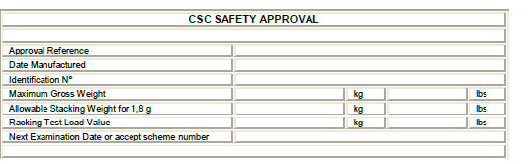

Customer Name:
Authorized Signatory Name:
Signature:
Date:

